- Project Title
Quotes Recommendation Chatbot using NLP

- Project Description
  - System Overview
The Quotes Recommendation Chatbot is an intelligent application designed to provide users with relevant and inspirational quotes based on their input. The system uses Natural Language Processing (NLP) techniques to understand user queries such as mood, topic, or keywords. After analyzing the input, the chatbot searches a quotes dataset and recommends suitable quotes to the user. The system consists of a frontend interface where users interact with the chatbot and a backend that processes requests and generates responses. This application aims to provide motivation, inspiration, and meaningful content to users quickly and efficiently through an interactive chatbot interface.
2.2 Problem Domain
Many people look for motivational, inspirational, or meaningful quotes for personal motivation, social media posts, or daily inspiration. However, finding relevant quotes quickly from large collections can be difficult and time-consuming. Traditional search methods often require users to browse many websites or books to find suitable quotes. This creates a need for an intelligent system that can understand user input and provide relevant quotes instantly. The Quotes Recommendation Chatbot solves this problem by using Natural Language Processing (NLP) to analyze user queries and recommend appropriate quotes based on mood, keywords, or topics, making the process faster and more convenient for users.

2.3 Core Technology Used
The Quotes Recommendation Chatbot is built using several modern technologies to process user input and provide relevant quote suggestions. Natural Language Processing (NLP) is used to understand and analyze the user’s text input, such as mood or keywords. The backend is developed using Python, which handles the processing logic and quote recommendation system. ReactJS is used to build an interactive and user-friendly frontend interface where users can chat with the system. Additionally, Generative AI can be integrated to generate or enhance quote responses. Libraries such as NLTK or spaCy help in text processing and keyword extraction, enabling the chatbot to deliver accurate and meaningful quote recommendations.
2.4 Key Capabilities
The Quotes Recommendation Chatbot has several key capabilities that allow it to provide useful and relevant quote suggestions. The system can understand user input such as mood, topic, or keywords using Natural Language Processing (NLP). It can quickly analyze the input and recommend suitable quotes from a dataset. The chatbot also provides an interactive interface where users can easily communicate with the system. Additionally, it can deliver instant responses, making the process of finding inspirational or motivational quotes fast and convenient. The system is designed to be simple, efficient, and user-friendly for all types of users.
2.5 Target Users (Short Brief):
The target users of the Quotes Recommendation Chatbot include students, writers, and social media users who often look for motivational or inspirational quotes. It is also useful for content creators, bloggers, and individuals who want meaningful quotes for personal motivation or sharing online. Additionally, teachers and educators can use the system to find quotes for presentations or educational purposes. The chatbot is designed to be simple and user-friendly, making it suitable for anyone who wants quick and relevant quote suggestions based on their mood or topic.
2.6 Real-World Relevance
The Quotes Recommendation Chatbot has practical importance in everyday life as it helps users quickly find inspirational and meaningful quotes. Many people use quotes for motivation, social media posts, speeches, and personal development. Instead of searching through multiple websites or books, this chatbot provides instant and relevant quote suggestions based on user input. It can be useful for students, professionals, content creators, and educators who need motivational content. By using Natural Language Processing (NLP), the system improves the user experience by delivering personalized and context-based quotes, making it a helpful tool for inspiration and communication in the digital world.

03. Application Scenarios / Use cases
There are four real-world implementation scenarios
3.1. Enterprise Usage:
Organizations can use the Quotes Recommendation Chatbot to provide motivational content for employees. Companies can integrate the chatbot into internal communication platforms to share daily inspirational quotes that improve employee morale, productivity, and workplace positivity.
3.2. End – User Usage:
Individuals can use the chatbot to quickly find motivational or inspirational quotes based on their mood or interests. It can help users get daily motivation, create social media posts, or find meaningful quotes for personal inspiration.
3.3. Educational Usage:
Teachers and students can use the chatbot to find quotes for presentations, assignments, speeches, or educational content. It helps students discover quotes related to learning, success, and personal development.
3.4. Industrial Usage:
Content creation industries such as digital marketing, blogging, and social media management can use the chatbot to quickly generate relevant quotes for campaigns, articles, and online content, saving time and improving creativity.

04. TECHNICAL ARCHITECTURE OVERVIEW
4.1 High-level Architecture Diagram
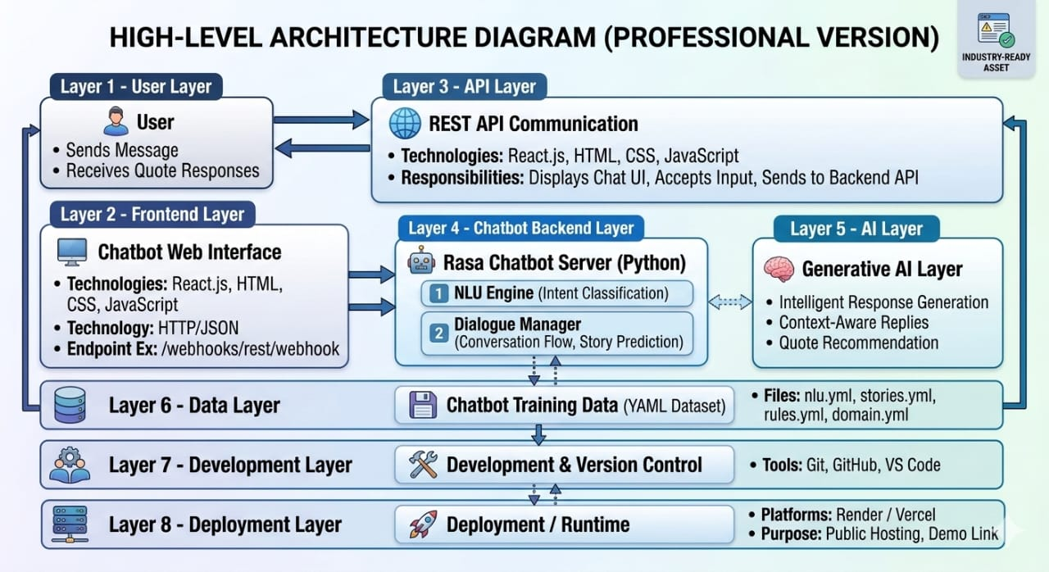
4.2 Component Interaction Diagram
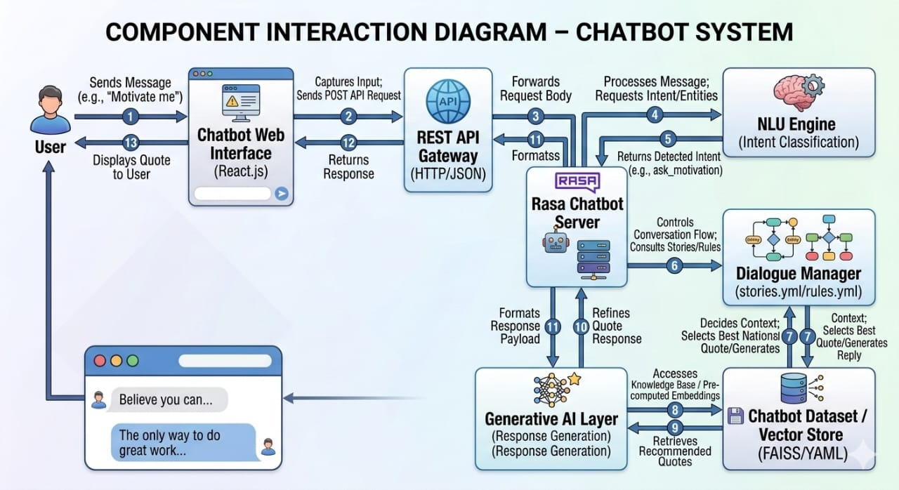

4.3 Data / Request Flow
Explain:
- Frontend Layer
The frontend layer is the user interface of the system where users interact with the chatbot. It is responsible for collecting user input and displaying the recommended quotes. In this project, ReactJS is used to create a responsive and user-friendly interface. It allows users to enter their mood or keywords and view the chatbot responses in an interactive chat format.
- Backend Layer
The backend layer handles the core processing and logic of the application. It receives user input from the frontend, processes it using Python and Natural Language Processing (NLP) techniques, and finds relevant quotes from the dataset. The backend also manages the chatbot response generation and sends the results back to the frontend.
- Database Layer (If Applicable)
The database layer stores the collection of quotes used by the chatbot. It can be a CSV file, JSON dataset, or a database like SQLite or MongoDB. The backend searches this dataset to find quotes that match the user’s input keywords or mood.
- External APIs / Services
External APIs or services can be integrated to enhance the chatbot’s capabilities. For example, Generative AI APIs can be used to generate new quotes or improve responses. These services help make the chatbot more intelligent and dynamic.
- Deployment Environment
The deployment environment refers to where the application is hosted and made accessible to users. The project can be deployed on platforms such as GitHub, Render, Vercel, or cloud services. These platforms allow the chatbot to run online so users can access it through a web browser.

5. PREREQUISITES
  - Software Requirements
5.1.1 Development Tools:
Development tools are used to build and manage the project. In this project, tools such as Git for version control and Node Package Manager (NPM) for managing dependencies are used. These tools help in organizing the code and managing project files efficiently.
5.1.2 IDE (Integrated Development Environment):
An IDE is used to write, edit, and debug the program code. For this project, Visual Studio Code (VS Code) is used because it provides useful features such as code suggestions, extensions, debugging tools, and easy project management.
    - Runtime Environment:
The runtime environment is required to execute the program. Python is used for backend processing and NLP tasks, while Node.js is used to run the ReactJS frontend application. These environments allow the application to run smoothly.
    - Cloud Services (If Any):
Cloud platforms can be used to host and deploy the chatbot application. Services such as GitHub for code hosting and Render or Vercel for application deployment can be used to make the chatbot accessible online.

5.2 Libraries / Frameworks / Dependencies
The following libraries, frameworks, and dependencies are used in the development of the Quotes Recommendation Chatbot:
Backend Libraries (Python):
- Flask – Used to create the backend server and handle API requests.
- NLTK (Natural Language Toolkit) – Used for Natural Language Processing tasks such as tokenization and text analysis.
- Pandas – Used for handling and processing the quotes dataset.
- Scikit-learn – Used for text similarity and recommendation logic.
- NumPy – Used for numerical operations and data processing.
Fronted Libraries (ReactJS):
- Axios – Used to send requests from the frontend to the backend API.
- CSS / Bootstrap – Used for styling and responsive design.
Frontend ReactJS – Used to build the interactive user interface of the chatbot.
Other Dependencies:
- Node.js & NPM – Used to manage frontend packages and run the React application.
- Python Virtual Environment (venv) – Used to manage project dependencies separately
These libraries and frameworks help in building the chatbot, processing user input, and providing accurate quote recommendations.

5.3 Hardware Requirements (If Applicable)
5.3.1 System Specifications:
To develop and run the Quotes Recommendation Chatbot, a standard computer system is required. The recommended specifications include a processor such as Intel i3 or higher, minimum 4 GB RAM, and at least 10 GB of free storage for installing development tools, libraries, and datasets. A stable internet connection is also required for downloading dependencies and deploying the application.
5.3.2 Devices / Sensors:
This project does not require any special hardware devices or sensors because it is a software-based application. It can run on a laptop or desktop computer using a web browser for user interaction.

6. PRIOR KNOWLEDGE REQUIRED
Before implementing the Quotes Recommendation Chatbot, some basic technical knowledge is required.
6.1 Programming Language Knowledge:
Basic knowledge of Python and JavaScript is required to develop the backend and frontend of the application. Understanding concepts such as variables, functions, loops, and data structures is important for implementing the project logic.
6.2 Framework Basics:
Knowledge of frameworks such as Flask for backend development and ReactJS for frontend development is helpful. These frameworks are used to create the application structure and manage communication between the user interface and server.
6.3 Database Fundamentals:
Basic understanding of how data is stored and managed is required. Knowledge of working with datasets, CSV files, or simple databases helps in storing and retrieving quotes for the recommendation system.
6.4 Networking / Cloud Concepts:
Basic knowledge of HTTP requests, APIs, and cloud deployment is useful for connecting the frontend with the backend and hosting the application on online platforms.
6.5 AI/ML Fundamentals (If Applicables):
Basic understanding of Natural Language Processing (NLP) and machine learning concepts is helpful for processing user input and recommending relevant quotes.

7. PROJECT OBJECTIVES
7.1 Technical Objectives:
The main technical objective of this project is to develop a Quotes Recommendation Chatbot that can understand user input using Natural Language Processing (NLP) and provide relevant quote suggestions. The system aims to integrate a ReactJS frontend with a Python backend to create an interactive chatbot interface.

7.2 Performance Objectives :
The system should provide quick and accurate responses to user queries. It should efficiently process user input, analyze keywords, and recommend suitable quotes with minimal response time.
7.3 Deployment Objectives :
The objective is to deploy the chatbot on an online platform so that users can access it through a web browser. This involves hosting the application on platforms such as GitHub, Render, or Vercel for easy accessibility.
7.4 Learning Outcomes :
Through this project, students gain practical experience in Natural Language Processing, web development using ReactJS and Python, API integration, and deployment of applications. It also helps in understanding how AI-based systems are designed and implemented.

8. SYSTEM WORKFLOW
8.1 User Interaction :
The user interacts with the chatbot through the frontend interface by entering a mood, keyword, or topic for which they want a quote.
8.2 Input Handling :
The system receives the user input from the frontend and sends it to the backend server for processing.
8.3 Processing Logic :
The backend analyzes the user input using Natural Language Processing (NLP) techniques to extract important keywords or understand the user’s intent.
8.4 Core System Execution :
After processing the input, the system searches the quotes dataset and finds quotes that match the extracted keywords or user mood.
8.5 Output Generation :
The system selects the most relevant quotes and prepares them as a response.
8.6 Response Delivery :
Finally, the recommended quotes are sent back to the frontend and displayed to the user through the chatbot interface.

9. MILESTONE 1: REQUIREMENT ANALYSIS & SYSTEM DESIGN
9.1 Problem Definition
Many users search for motivational or inspirational quotes for personal motivation, social media posts, presentations, or learning purposes. However, finding relevant quotes from large collections is time-consuming and inefficient. Traditional search methods require users to browse multiple sources to find suitable quotes. Therefore, there is a need for an intelligent system that can understand user input and quickly recommend relevant quotes. The Quotes Recommendation Chatbot solves this problem by using Natural Language Processing (NLP) to analyze user queries and suggest appropriate quotes instantly.
9.2 Functional Requirements
The system should perform the following functions:
- Accept user input such as mood, topic, or keyword.
- Process the input using NLP techniques.
- Search the dataset for relevant quotes.
- Recommend suitable quotes to the user.
- Display the chatbot responses through the user interface.
9.2 Functional Requirements
The system should perform the following functions:
- Accept user input such as mood, topic, or keyword.
- Process the input using NLP techniques.
- Search the dataset for relevant quotes.
- Recommend suitable quotes to the user.
- Display the chatbot responses through the user interface.
9.3 Non-Functional Requirements
These requirements focus on system performance and usability:
- The system should provide fast response time.
- The user interface should be simple and user-friendly.
- The system should be reliable and easy to maintain.
- The application should handle multiple user queries efficiently.
9.4 System Design Decisions
The system is designed using a client–server architecture. The frontend interface is developed using ReactJS to provide a responsive user experience. The backend is developed using Python and Flask to process user input and manage the chatbot logic. NLP techniques are used to analyze text input and match it with relevant quotes from the dataset.
9.5 Technology Stack Selection Justification
The technology stack was selected based on efficiency and ease of development. Python is chosen for the backend because it provides strong support for NLP libraries. ReactJS is used for the frontend to build an interactive and dynamic user interface. Flask is selected as a lightweight backend framework that easily integrates with Python. These technologies together help create a fast, scalable, and user-friendly chatbot system.
Include :
- Architecture Diagram
The system follows a client–server architecture where the frontend, backend, and dataset interact with each other to process user requests. The user interacts with the chatbot through the frontend interface. The frontend sends the user input to the backend server through API requests. The backend processes the input using NLP techniques and searches the quotes dataset. After finding relevant quotes, the backend sends the response back to the frontend, which displays the results to the user.
- Basic Architecture Flow:
User
│
▼
Frontend (ReactJS)
│
▼
Backend API (Python / Flask)
│
▼
NLP Processing
│
▼
Quotes Dataset / Database
│
▼
Response sent to Frontend
│
▼
Displayed to User Author

- ER Diagram (Entity Relationship Diagram)
The ER diagram represents how data is organized in the system. In this project, the main entity is the Quotes dataset that stores quotes and related information.
Entities:
- User
- User_ID
- User_Input
- Mood / Topic
- Quotes
- Quote_ID
- Quote_Text
- Category
Relationship:
User → requests → Quotes
The user provides input, and the system retrieves relevant quotes from the dataset based on the input.

- API Structure (If Applicable)
APIs are used to communicate between the frontend and backend.
Example API Endpoints:
1. Get Quote Recommendation
POST /get_quote
Request Example:
{
"input": "motivation"
}
Response Example:
{
"quote": "The only way to achieve the impossible is to believe it is possible.",
"author": "Charles Kingsleigh"
}
This API receives the user input, processes it using NLP, and returns the most relevant quote.

10. MILESTONE 2: ENVIRONMENT SETUP & INITIAL CONFIGURATION
10.1 Development Environment Setup
The development environment is prepared to build and run the Quotes Recommendation Chatbot. The required tools include Python for backend development, Node.js for frontend development, and Visual Studio Code as the development environment. Git is used for version control and project management.

10.2 Dependency Installation
Required libraries and packages are installed to support the development of the chatbot system.
Backend Installation (Python):
pip install flask nltk pandas scikit-learn numpy
Frontend Installation (React):
npx create-react-app quotes-chatbot
cd quotes-chatbot
npm install axios
These dependencies allow the system to handle NLP processing, data management, and frontend-backend communication.

10.3 Project Structure Creation
Example project folder structure:
quotes-chatbot/
│
├── backend/
│ ├── app.py
│ ├── quotes_dataset.csv
│ └── requirements.txt
│
├── frontend/
│ ├── src/
│ ├── public/
│ └── package.json
│
├── static/
├── templates/
└── README.md
This structure separates the frontend and backend components for better organization.
10.4 Configuration Setup
The configuration setup includes connecting the frontend with the backend API and loading the quotes dataset.
Example backend configuration:
from flask import Flask
app = Flask(__name__)
The system also loads the quotes dataset during initialization to enable quick quote retrieval.

11. MILESTONE 3: CORE SYSTEM DEVELOPMENT
11.1 Feature 1 – User Input Handling
- Description
This feature allows users to enter a mood, keyword, or topic through the chatbot interface.
- Code Explanation
The frontend sends user input to the backend API using HTTP requests. The backend receives and processes the input.
Example:
@app.route('/get_quote', methods=['POST'])
def get_quote():
user_input = request.json['input']
Screenshots / Outputs
Screenshots of the chatbot interface and user input should be included in the report.
11.2 Feature 2 – NLP Processing and Quote Matching
Description
This feature processes the user input using NLP techniques to identify keywords and match them with relevant quotes in the dataset.
Example processing steps:
- Tokenization
- Keyword extraction
- Matching quotes
The system then selects the most suitable quotes based on similarity.
11.3 Feature 3 – Chatbot Response Generation
Description
After finding relevant quotes, the chatbot generates a response and sends it back to the user interface.
Example response format:
{
"quote": "Believe you can and you're halfway there.",
"author": "Theodore Roosevelt"
}
Database Schema (If Applicable)
Example dataset structure:
Quote_ID | Quote_Text | Author | Category
1 | Believe in yourself | Unknown | Motivation
2 | Success comes with hard work | Author Name | Success

- API Endpoints
Method | Endpoint | Description
POST | /get_quote | Returns recommended quote

Business Logic Layer
The business logic layer processes user input, applies NLP techniques, and retrieves relevant quotes from the dataset.
Steps:
- Receive user input
- Process text using NLP
- Search dataset
- Select best quote
- Return response

12. MILESTONE 4: INTEGRATION & OPTIMIZATION
12.1 Component Integration
The frontend and backend components are integrated using REST APIs. The ReactJS frontend sends user requests to the Flask backend, which processes the request and returns the results.

12.2 Performance Optimization
Performance is improved by optimizing the NLP processing and reducing unnecessary computations. Efficient search techniques are used to quickly retrieve quotes from the dataset.

Test Case ID | Input | Expected Output | Status
TC01 | motivation | Motivational quote displayed | Pass
TC02 | success | Success-related quote displayed | Pass
TC03 | happiness | Inspirational quote about happiness | Pass
TC04 | random text | System handles input and returns closest quote | Pass
TC05 | empty input | Error message or request for valid input | Pass

12.3 Security Enhancements
Basic security measures such as input validation and safe API handling are implemented to prevent incorrect or malicious inputs.

12.4 Error Handling & Validation
The system includes error handling to manage invalid inputs or server issues. Validation checks ensure that the user input is processed correctly and meaningful responses are returned.

13. MILESTONE 5: TESTING & VALIDATION
13.1 Test Cases
The system is tested using different user inputs to verify whether the chatbot provides relevant quote recommendations.
13.2 Unit Testing
Unit testing is performed to verify the individual components of the system. Each function, such as input processing, NLP keyword extraction, and quote retrieval, is tested separately to ensure they work correctly. This helps identify errors in small sections of the code before integrating the entire system.
13.3 Integration Testing
Integration testing ensures that different components of the system work together properly. The frontend interface is tested with the backend API to verify that user input is correctly sent to the server and the recommended quotes are returned and displayed properly.

13.4 User Acceptance Testing
User Acceptance Testing (UAT) is performed to ensure the system meets user expectations. Users interact with the chatbot by entering different moods or topics and verifying whether the chatbot returns meaningful and relevant quotes.

13.5 Performance Metrics
To evaluate the effectiveness of the system, several performance metrics are considered.
- Accuracy:
Measures how often the system provides relevant quotes based on user input.
- Precision:
Indicates the proportion of recommended quotes that are actually relevant to the user's request.
- Recall:
Measures how many relevant quotes from the dataset are successfully retrieved by the system.

14. DEPLOYMENT
14.1 Deployment Architecture
The deployment architecture describes how the system is hosted and accessed by users. The frontend application built with ReactJS is deployed on a web hosting platform, while the backend developed using Python and Flask runs on a server that processes user requests. The frontend communicates with the backend through API calls to retrieve quote recommendations.

14.2 Hosting Platform
The project can be hosted on platforms such as GitHub for code repository, Vercel for frontend deployment, and Render or Heroku for backend hosting. These platforms allow the chatbot to run online and be accessible through a web browser.
14.3 Deployment Steps
- Upload the project code to a GitHub repository.
- Deploy the frontend React application on Vercel.
- Deploy the backend Flask application on Render or another cloud platform.
- Connect the frontend with the backend API.
- Test the application to ensure it works correctly online.

14.4 Production Considerations
Before deploying the system for public use, several factors must be considered such as system performance, security, error handling, and scalability. Regular updates and monitoring help maintain the system’s reliability.

15. PROJECT STRUCTURE
Example folder structure:
project_root/
│
├── backend/
│ ├── app.py
│ ├── quotes_dataset.csv
│ └── requirements.txt
│
├── frontend/
│ ├── src/
│ ├── public/
│ └── package.json
│
├── static/
├── templates/
├── tests/
└── README.md
Explanation:
- backend/ – Contains the Python Flask server and NLP processing logic.
- frontend/ – Contains the ReactJS user interface.
- static/ – Stores static files like CSS and images.
- templates/ – Contains HTML templates (if required).
- tests/ – Contains test scripts for system testing.
- README.md – Contains project documentation.

16. RESULTS
The Quotes Recommendation Chatbot successfully provides relevant quotes based on user input. The system processes user queries using NLP techniques and retrieves appropriate quotes from the dataset. The chatbot interface allows users to easily interact with the system and receive instant responses.
Results include:
- Accurate quote recommendations
- Fast response time
- User-friendly chatbot interface

17. ADVANTAGES & LIMITATIONS
Advantages
- Provides quick and relevant quote recommendations
- User-friendly chatbot interface
- Saves time compared to manual search
- Can be used for motivation, learning, and content creation
Limitations
- Limited to the available quotes dataset
- May not fully understand complex user inputs
- Accuracy depends on the quality of NLP processing

18. FUTURE ENHANCEMENTS
- Integration with advanced AI models for better recommendations
- Voice-based chatbot interaction
- Mobile application version
- Cloud-based scalable deployment
- Personalized recommendations based on user preferences

19. CONCLUSION
The Quotes Recommendation Chatbot using NLP is designed to provide users with relevant and inspirational quotes based on their input. The system combines Natural Language Processing techniques with a user-friendly web interface to deliver quick and meaningful responses. Through this project, important concepts of NLP, web development, and chatbot systems were implemented and understood. The project demonstrates how AI-based technologies can be used to create practical applications that enhance user experience and provide useful information efficiently.

20. APPENDIX

● Source Code : https://github.com/pragati-003/Quotes-Recommendation-Chatbot
● Configuration Files : https://github.com/pragati-003/Quotes-Recommendation-Chatbot/blob/master/config.yml
● Dataset Details: https://github.com/pragati-003/Quotes-Recommendation-Chatbot/blob/master/data/nlu.yml
● GitHub Repository Link : https://github.com/pragati-003/Quotes-Recommendation-Chatbot
● Live Demo Link : https://drive.google.com/file/d/1emDkIpMabuXtK36-00WhbEfphVI7WBK9/view

